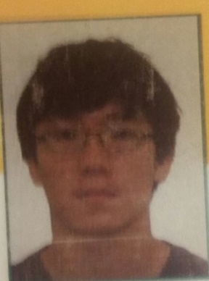Samuel Kim

[skim103@gmu.edu](mailto:skim103@gmu.edu)

Wrote an online version of an employee directory with another developer (Summer Internship 2015)

Some JavaScript, SQL, Kendo UI, HTML experience.

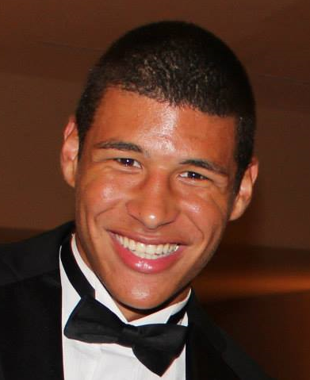

Marcus Domingo

[mdomingo@masonlive.gmu.edu](mailto:mdomingo@masonlive.gmu.edu)

Designed and wrote code for a video game on a 300x280 pixel screen on a team of 4 for CS 101.

Created a POS system for a grocery store; Java, C, C++, HTML experience.

Team Leader: Courtney Olson

The main reason why we voted Courtney for team leader is because she has the most experience out of all of the group members. She already has acquired a B.S. degree for SMAD (School of Media Arts and Design) which she mainly focused on web design and film. She has also had the most experience working in large groups as well as leading the large groups. That’s why we believe she is the best choice for the team leader.

Primary Meeting Time: Monday 11:30am – 12:45pm

Skype Meeting Time (if necessary): Friday Nights

Secondary Meeting Time (if necessary): 10:00am – 11:30am